DROP!

CPE 202L

OBJECT ORIENTED PROGRAMMING

GROUP 2

Prepared By:

Aguilar, Paul Christian

Cervantes, John Paul

De Jesus, Ronie

Esguerra, Joshua Mark

Mendoza, Melissa

Pagtalunan, Jonas

Santos, Kristian A.

Soledad, Ramon

BSCpE-2B

December, 2019

INTRODUCTION

DROP! is a game developed in Python using the Pygame library that has one goal: Get the astronaut down the platforms as fast as you can and avoid the spikes at the top of the screen. There is only one game mode: Endless. The longer the play time, the faster the platforms will go up which increases the chance of getting impaled by the spikes. There are 2 powerups: Teleport and Slowdown Platforms. Teleport powerup instantly moves the player position one platform down while the slowdown platforms powerup halves the speed of the platforms.

**CHAPTER 1: Directory contents**

There are different modules and assets that are vital for the game to run:

@ Drop directory:

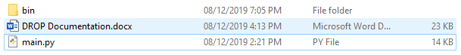

Main.py is the main module that holds all of the different modules and assets which are inside the bin folder.

@ bin Directory:

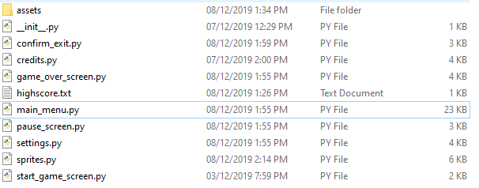

__init__.py is the script responsible for converting the entire directory into a package to be easily accessed by the main script outside the directory. The names of the other scripts explain what their functions are. It will all be explained later once the program logistics are explained.

The assets folder contains the sounds and images used to add life to the game itself.

**CHAPTER 2: Program Flow**

To better understand the flow of the program: